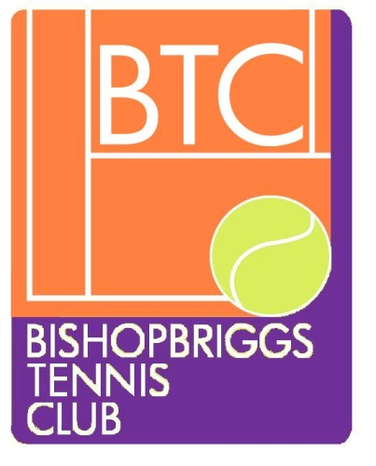

RECRUITMENT OF COACHES AND WELFARE OFFICER

Bishopbriggs Tennis Club has Safeguarding and Protection policies in place regarding children/young adults.
Coaches and Welfare Officer have Disclosure Scotland approval for working with children and vulnerable adults.
Coaches and Welfare Officer have attended training on Safeguarding Children and Vulnerable Groups in Tennis (run by LTA).
Coaches have First Aid certificate
Our coaches have accreditation via the Lawn Tennis Association
New coaches to club will have an update check (PVG) and will have to provide 2 references. 1 from their previous tennis club/Tennis Scotland.

President Jacqueline Martin 19/03/19

Vice President Susan Heaney 19/03/19

Welfare Officer Jacqueline Martin 19/03/19

