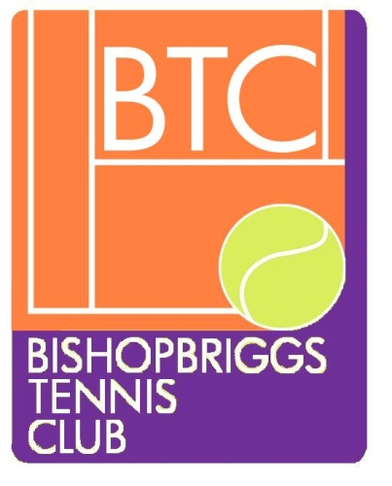
BISHOPBRIGGS TENNIS CLUB RULES

2020-Restricted play

The club has a number of rules aimed at making sure everyone is safe and can enjoy their tennis. The rules also are to ensure facilities and equipment are maintained in a good condition and to comply with COVID 19 Guidelines.

1)CRTS 1 and 3 will be open for play. Children of primary school age require to be supervised by an adult at all times.

2)Social Distancing and Hygiene rules apply at all times. WASH/SANITISE HAND PRIOR TO ENTERING COURTS. if you are opening padlocks best to sanitise hands again after doing this. (sanitiser will be available however best to bring your own)

3)Mostly play will be SINGLES but DOUBLES PLAY is permitted for family groups and 2 people from the same household playing against 2 players from another household. At all times players should change ends at opposite sides of the net to maintain 2m distancing. When playing stay back 1m from net -especially when playing doubles.

4) Bring your own MARKED TENNIS BALLS and only serve with/handle these. At all other times use your racquet to pass your opponent’s ball back to them or to pass ball back to players from another court.

5)BOOKING will be made on Clubspark and be for 1 hr. Booking can only be made 1 week in advance and we request that you show consideration for others and don’t book out the same time 7 days / week!! MEMBERSHIP FEES must be paid before BOOKING/PLAYING.
Players are asked to VACATE court 5 minutes before the next player’s booking. In the event that no-one arrives to play on your court at the end of the hour, you are welcome to stay on.(you can check Clubspark on your phone) If you decide not to use your booking, please cancel this so others may use it.(not necessary if weather inclement)

6)When ARRIVING at courts do not go onto courts until previous players vacate the courts. Ideally arrive 5 minutes before your allocated time and stand at the side of the clubhouse or outwith club area so that you maintain social distancing and that allows players on court time to exit whilst maintaining social distance.

7)APPROPRIATE FOOTWEAR without studs/ridges must be worn on clay courts to prevent damage to the surface. NO FOOTBALL/RUGBY TOPS please.

8)Members may be issued with SHOETAGS as proof of membership. If issued they must be worn.

9)If the courts are WET or have puddles on them do not play or you could damage the surface

10)During play DO NOT LEAN ON THE NETS as this may cause damage. Do not attempt to adjust net height.

11)DO NOT WALK ACROSS OR BEHIND COURTS when people are playing. Wait until the point is completed and players have time to social distance before crossing behind a court.

12) Please remove all your personal belongings including any LITTER/BOTTLES and take home with you to dispose of them.

13)When you have completed play ensure you have pulled the DRAGMAT over the courts to ensure surface is good for next players. (sanitise hands again before and after or wear gloves.)

14) VISITORS are allowed if you email (membership@bishopbriggstc.com) prior to this. A visitor can come twice -thereafter they will have to become a member to play on future occasions.

15) Please LOCK both PADLOCKS if you are last to leave the club. (even if there are later bookings). When you open the padlock turn the dial so that code is not visible to nonmembers/passers-by. Equally do not share code with non members.

16) Players/visitors must not use abusive language or be under the influence of alcohol or drugs whilst on club premises.

17) All players must comply with the CLUBS CODE OF CONDUCT which encompasses Safeguarding/Protecting Children and Vulnerable Adults, Inclusion and Diversity Policy and LTAs Fairplay. These policies /guidelines can be viewed on the Clubs Website. Please familiarise yourself with them.

18) Please adhere to club rules/COVID guidelines or this may affect your membership of the club.

19) ENJOY your tennis!!

